TOPIC 1: TELEVISION
Part 1. Introduction - 0.4 pt (~3 ideas):
Part 2. Cue pictures (Vocabulary) – 1.0 pt (~5 questions):
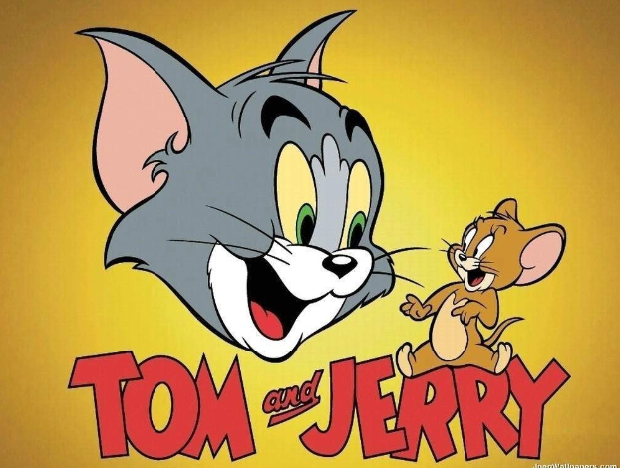  12  11 |   21 |   31 |   41
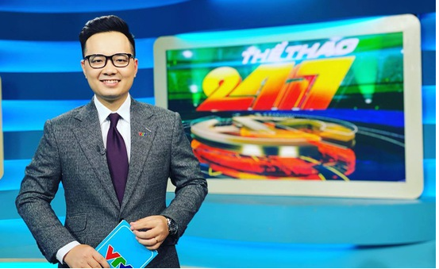 | Q1: What kind of film is it? (Picture 1)  Q2: What is it? (Picture 7)  Q3: Which symbol is it? (Picture 3,10)  Q4: How do you spell this word? (Picture 5,11)  Q5: A show which chooses the best talented person? (Picture 2)  Q6: “ Who wants to be a millionaire?” is a……… (Picture 8)  Q7: A programme is about sport/game? (Picture 4,12)  Q8: A film/show which makes people laugh? (Picture 6)  Q9: A person who watches TV? (Picture 9) |  | 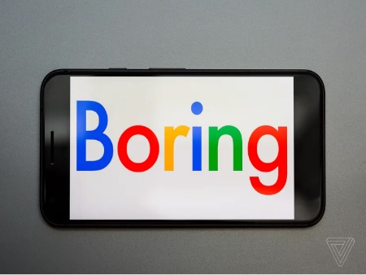  51
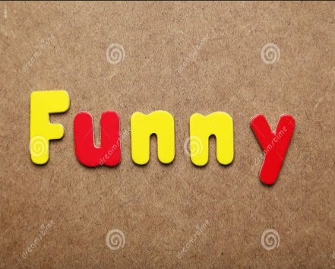  111 |  |  | 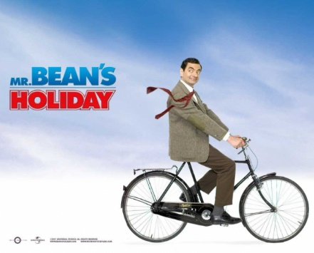  61
  101 | 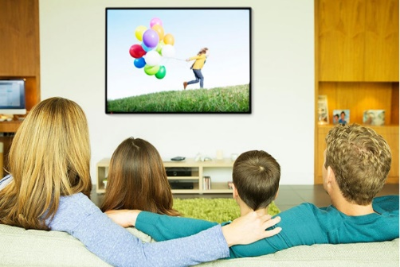  91 | 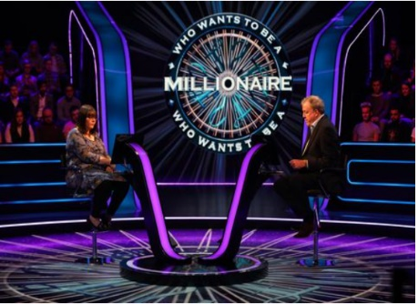  81 |   71

Key:
1 | 2 | 3 | 4 | 5 | 6 | 7 | 8 | 9 | 10 | 11 | 12
cartoon | talent show | boring | music programme | boring ( spell) | comedy | channel | game show | viewer | funny | funny(spell) | sports programme

Part 3. Role-play – 0.6 pt (~3 questions/ 1 student)
1. Yes, I do./ No, I don’t.
1. Do you like watching TV?

2. It’s/ My favorite TV programme is …….
2. What’s your favorite TV programme?

3. Sometimes/Usually/Always…….
3. How often do you watch TV?
4. On the weekend./ On Sundays……
4. When do you often watch TV?
6. An hour/ two hours/ 30 minutes………….
5. With my family/ my sister/my brother……
6. How many hours a day do you watch TV?
5. Who do you watch TV with?

