TOPIC 3 : CITIES OF THE WORLD
I. INTRODUCTION: 0.4pt
II. TOPIC SPEAKING 1.0pt
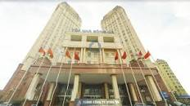  1 | 2  EXCITING | 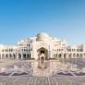  3 | 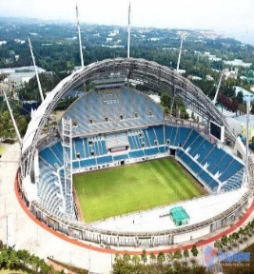  4
LANDMARK  12 | Q1+2/ What is this? (Reuse/ Recycle/ Reduce/ Shopping bag) (Pic.3, 1, 6, 4)  Q3/ How do you spell this word? (Pic. 2 ,7)  Q4/1. What is the street like ? (Pic.5)  2. What city is it ? (Pic.12)  - Where is it?(Pic.9)  4. What is Hoi An famous for ? (Pic.8)  Q5/ 1. Big Ben is a........................in London (Pic.12)  - This is a………................in Bangkok (Pic.11) |  | 5  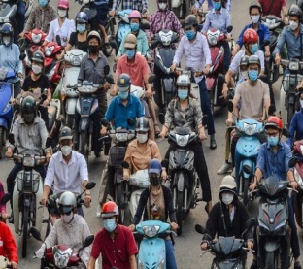
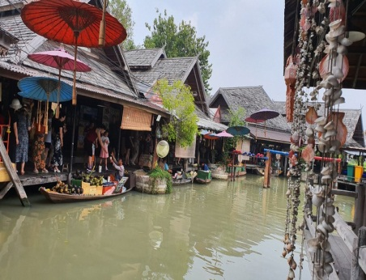  11 |  |  | 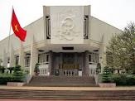  6
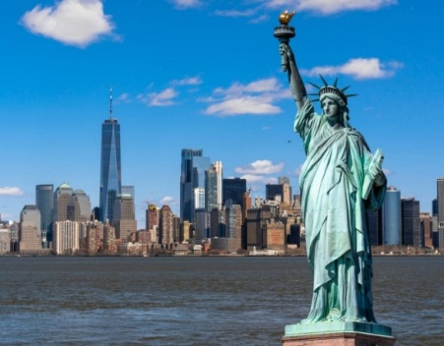  10 | 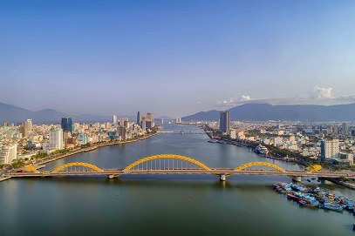  9 | 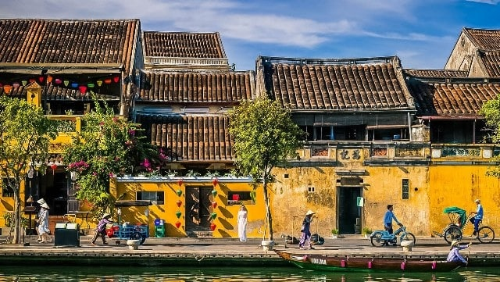  8 | 7  NOISY

KEY:
- a building  3. a palace | 4. a stadium  5. crowded  6. a museum | 8. old houses  9. Da Nang  10. NewYork | 11. floating market  12. landmark

III. INTERVIEW ( 0.6pt)
1. Do you like living in a city ? | Yes/No….
2. Which landmark do you love in Da Nang? | Dragon Bridge....
3. Which city is the biggest in Viet Nam ? | Ho Chi Minh city
4. How often do you go to Da Nang city? | ( Students’ answers)
5. Is Hoi An an old city ? Where is it ? | Yes, it is. In Quang Nam
6. What city do you like to visit most ? Why ? | ( Students’ answers)

