TOPIC 4 : OUR HOUSES IN THE FUTURE
Part 1. Introduction - 0.4 pt (~3 ideas):
Part 2. Cue pictures (Vocabulary) – 1.0 pt (~5 questions):
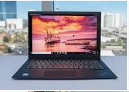 1 | 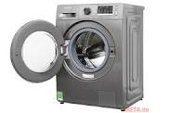 2 | 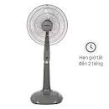 3 | 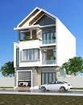 4
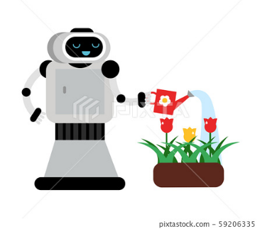12 | Q1,2: what is this? (Picture 1, 3, 9,10)  Q3: How do you spell this word? (Picture 4,5)  Q4: what is the robot doing? (Picture 12)  - What is he doing?(Picture 11)  - What are the children doing? (Picture 8)  - What might he do?(Picture 7)  Q5: A thing to cook rice is……(Picture 6)  Q6 :A thing to wash and dry clothes is…..(Picture 2) |  | 5  Iron
 11 |  |  | 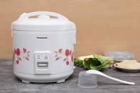 6
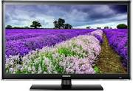 10 | 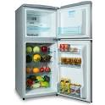9 |   8 |   7
KEY: 1. Computer 2. Washing machine 3. Fan 4. H- O-U- S-E 5. I- R O- N 6. Cooker 7. (He might) travel to the moon 8.( They are ) doing the housework 9. Fridge 10. Tv 11. (He is ) painting 12. ( He is) watering the flowers
II. ROLE PLAY: (0,6 pt)
- I want to have a villa.( flat/ modern house…
1.What types of future house do you want to have hhavhave

2. it will be in the city/ in the countryside……
2.where will it be?

3.It will be ……..
3.What will it look like?
4.It will have 4( 3) rooms………….
4. How many rooms will it have?
6. It will help me do the housework….
5.It will have smart TV……….
6.What will the appliances help you to do?
5. What appliances will it have ?

